VISUALIZATION TOOL FOR ELECTRIC VEHICLE CHARGE AND RANGE ANALYSIS

1.INTRODUCTION

1.1 overview

Electric vehicle control our air pollution.Automatically balancing energy usage.

Driving and electric car significantly smoother and quitter.

Maintanance cost lower .Electric vehicle use to charge there batteries instead of using fossil fuels like petrol or disel.

1.2.Purpose

Electric vehicle charging supply of direct current to the battery pack. As electricity distribution system supply alternate current power,A converter is required to provide DC power to the battery.

2.Problem Definition & Design thinking

2.1 Empathy map

Empathy map screenshot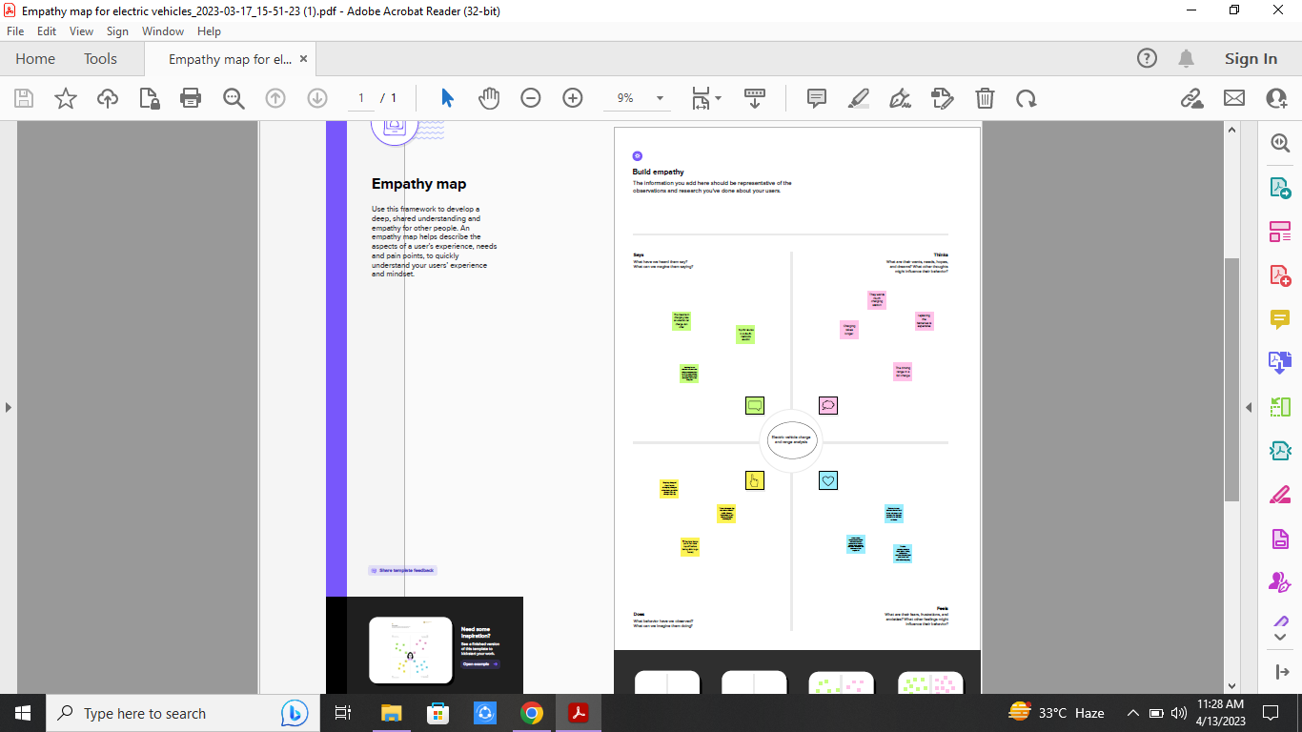

2.2 Ideation & Brainstorming map

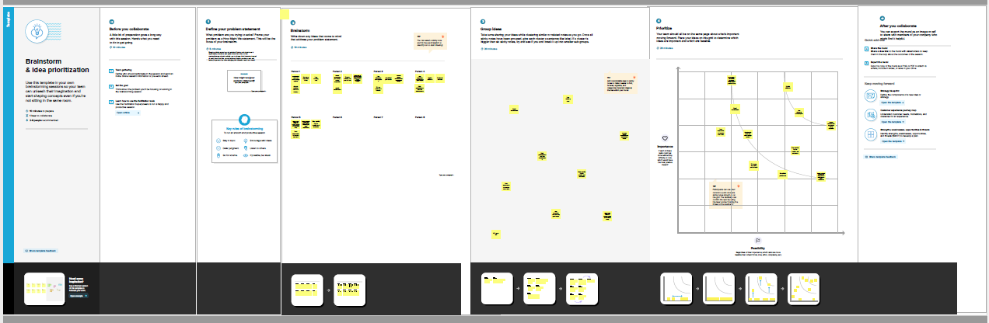

3.Result

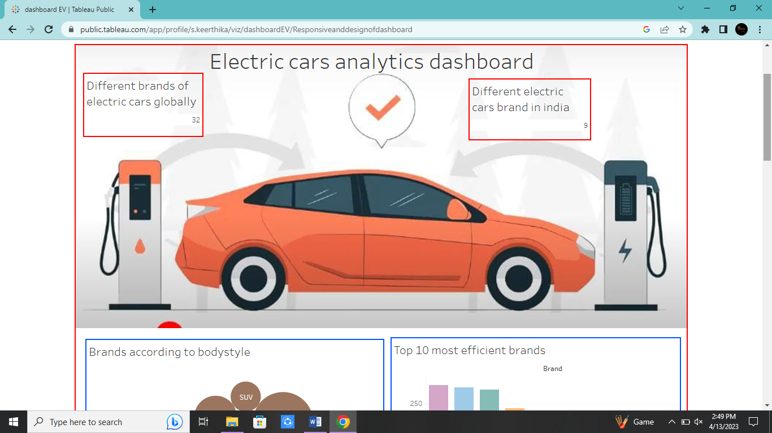

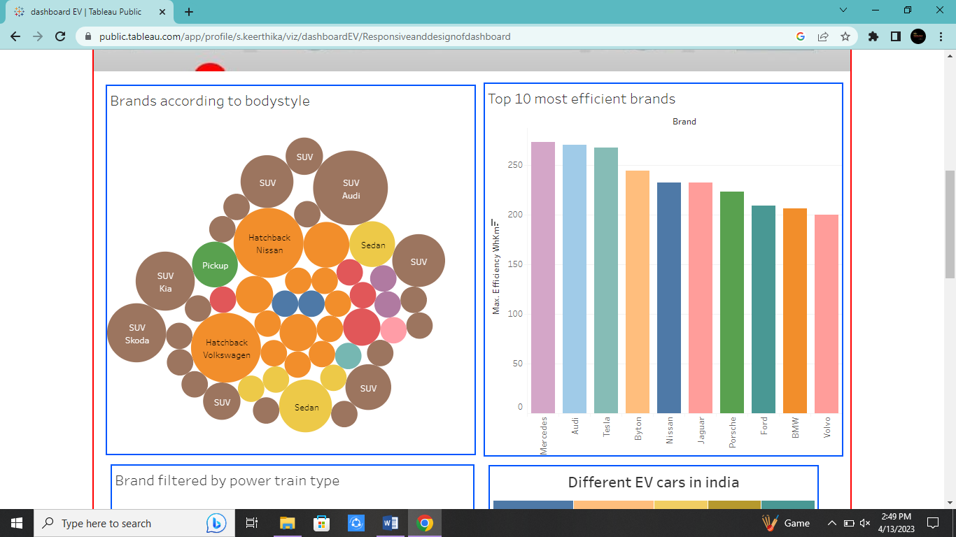

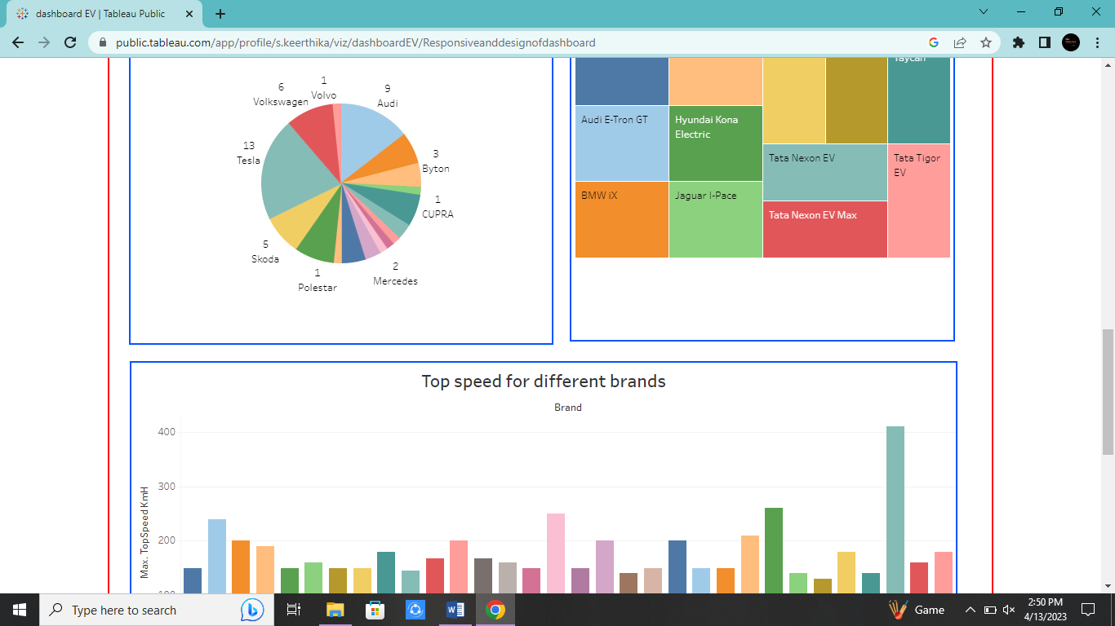

4. Advantages & Disadvantages

Advantage;

Connectivity of EV charging stations

Balance your energy flow

Save on electricity costs

Optimize sustainable energy usage

Reduce pollution

Disadvantage;

Environmental impact

More expensive to buy

Battery lifespan concerns

Low top speeds

Long charging times

5.APPLICATIONS

Electric train

Electric cycle

Electric aeroplane

Electric helicopter

Electric bike

6.CONCLUSION

Environmental benefits of electric cars the science is increasingly clear.

Good equipments should be used such as resistors, connecting wires,voltage supply and multitester.

7.FUTURE SCOPE

Clean and clear city

Environmental pollution is reduced

Stay safe stay healthy.

8.APPENDIX

A.Source code

https://drive.google.com/drive/folders/1YB8vqj8UgbAMZol3TkAzjTKXflqtIuq5?usp=share_link